Project Title: DSA Explorer and Visualiser App
7170_ST2 Group 5
U3295318 | U3308921
Automated Test Cases and Validation Scenarios:
Module 1: Data Structures Test Plan:
Test Case: Stack push/pop sequence:
Description: Push 3 times, pop 2
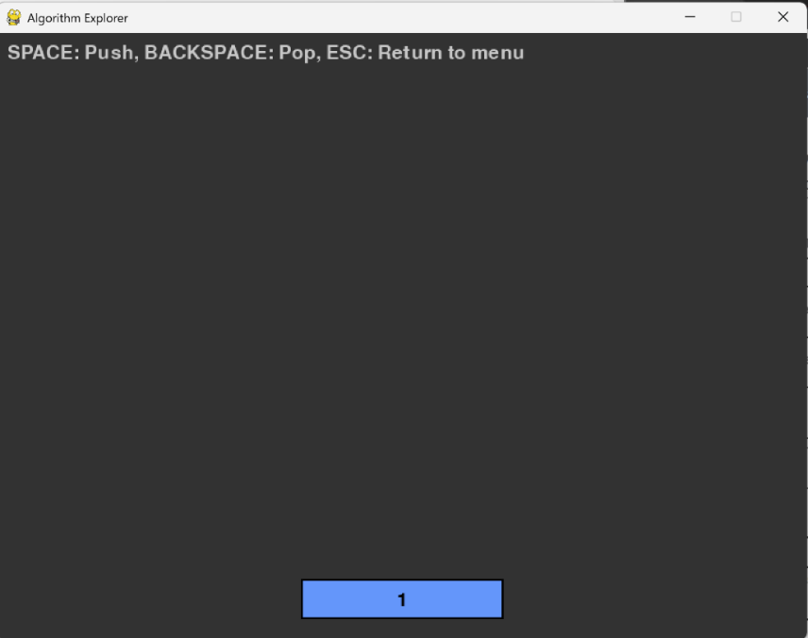
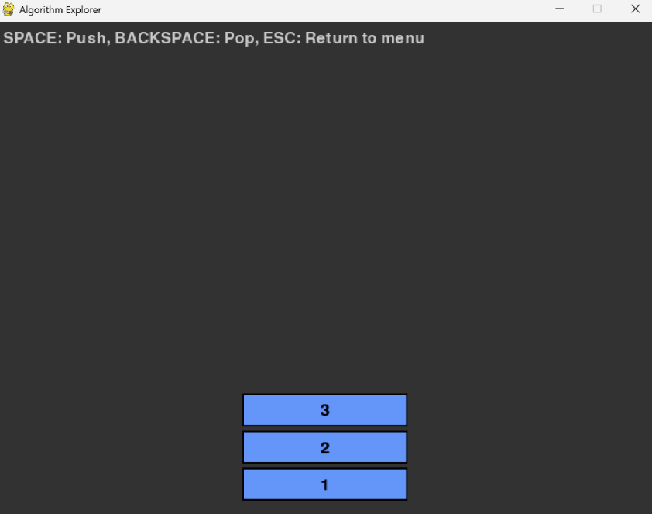
Expected Result: Final stack size=1, correct order.

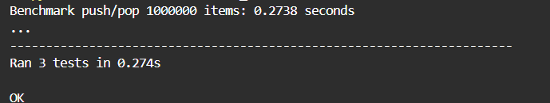
Test Case: Queue enqueue/dequeue
Description: Enqueue 4 items, dequeue 3
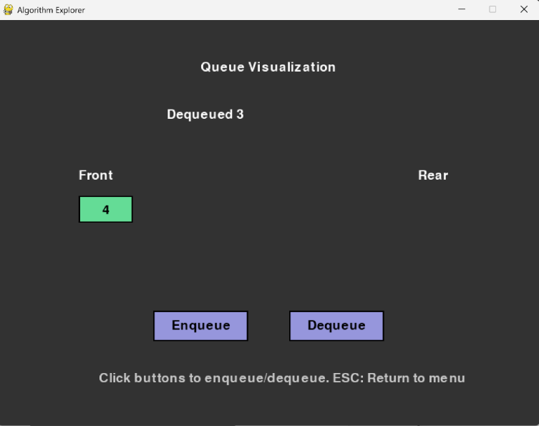
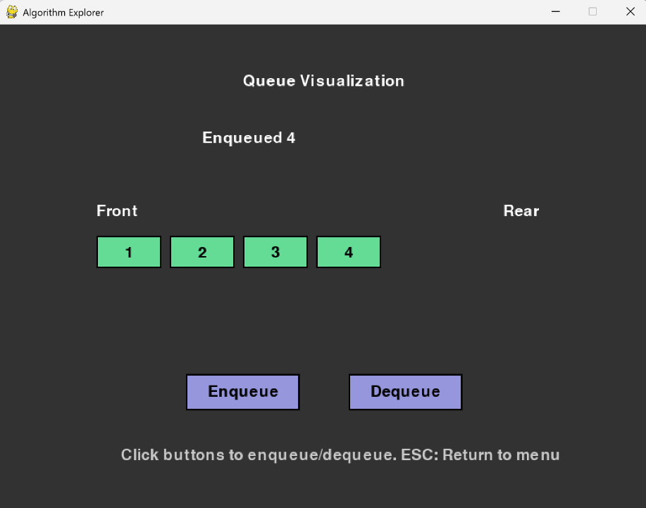
Expected Result: FIFO order maintained
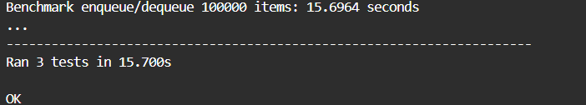
Test Case: Linked list insertion at position
Description: Insert node with value 10 at position 2
Expected Result: Node present in correct location in list.
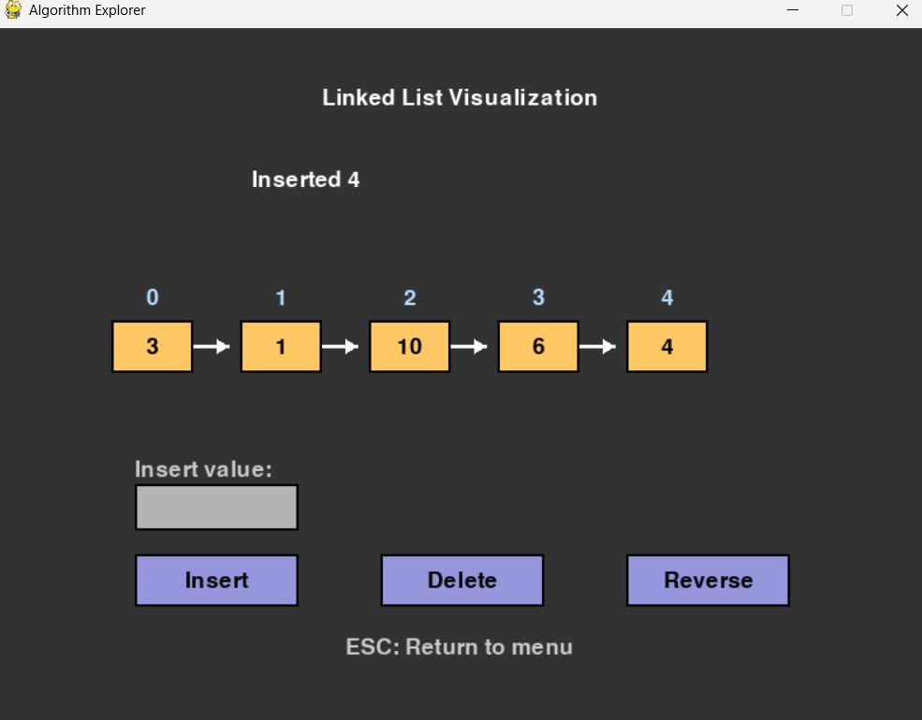
Test Case: BST insert and inorder traversal
Description: Insert [50,30,70]; inorder traversal
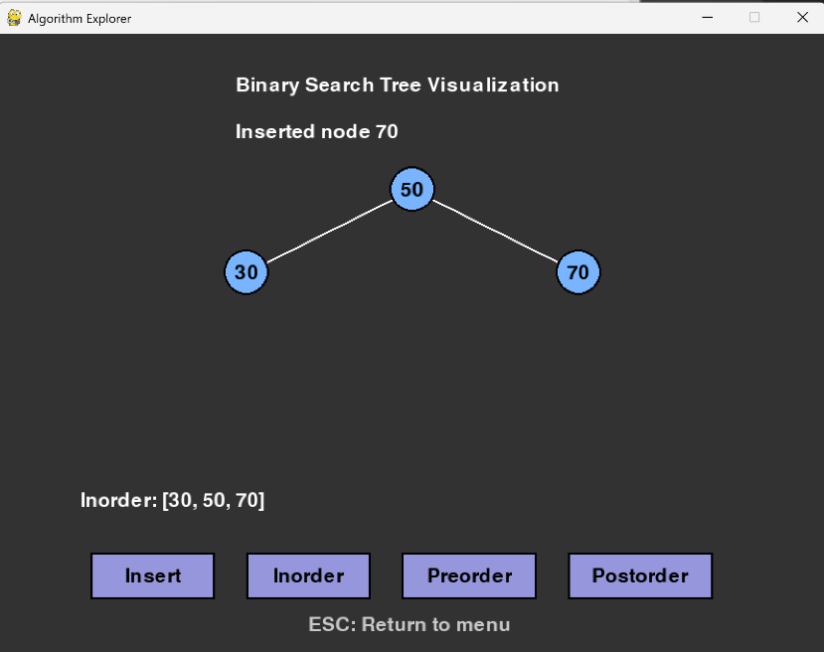
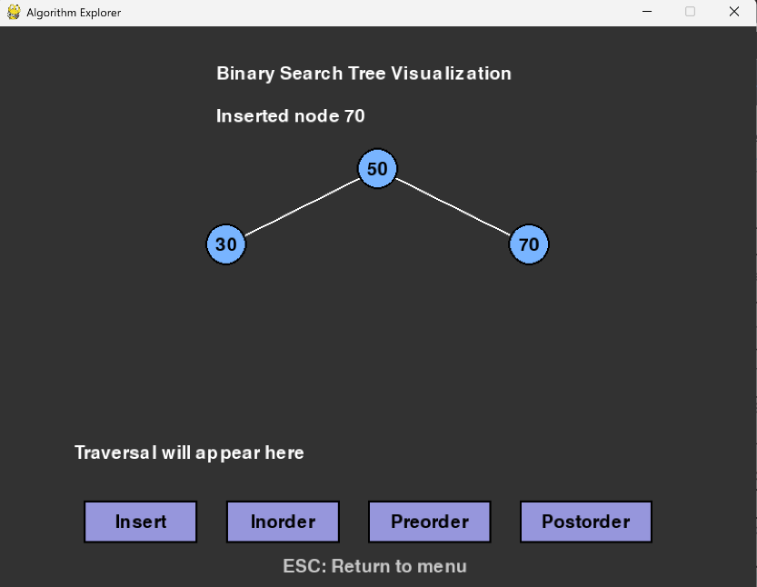
Expected Result: Traversal order: 30,50,70

Module 2: Sorting Test Plan:
Test Case: Bubble sort correctness
Description: sort array of [5,3,8,1,2]
Expected Result: Sorted array: [1,2,3,5,8]
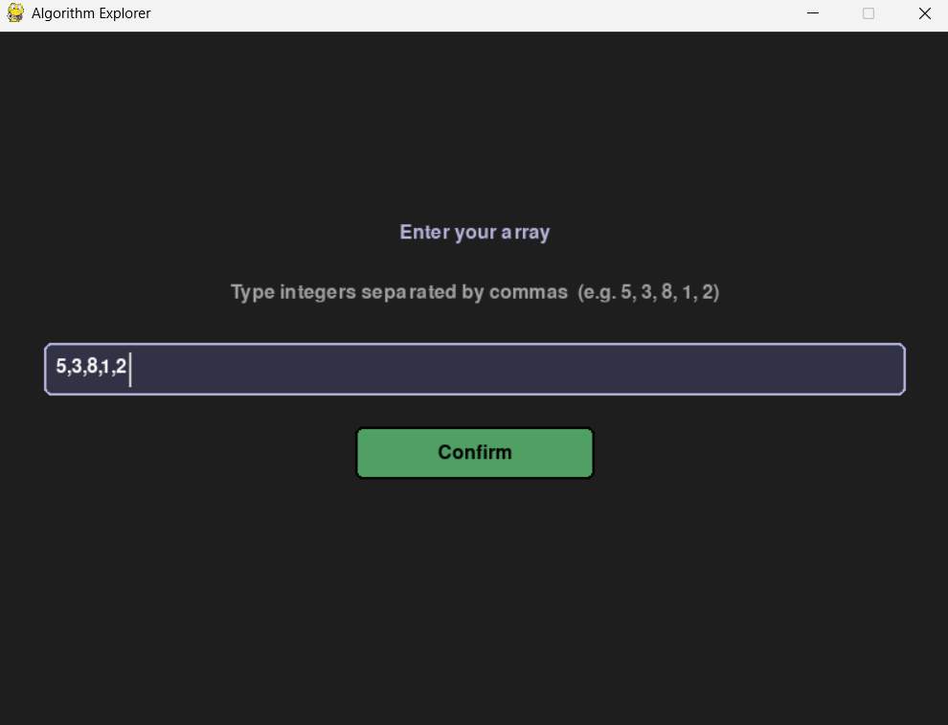
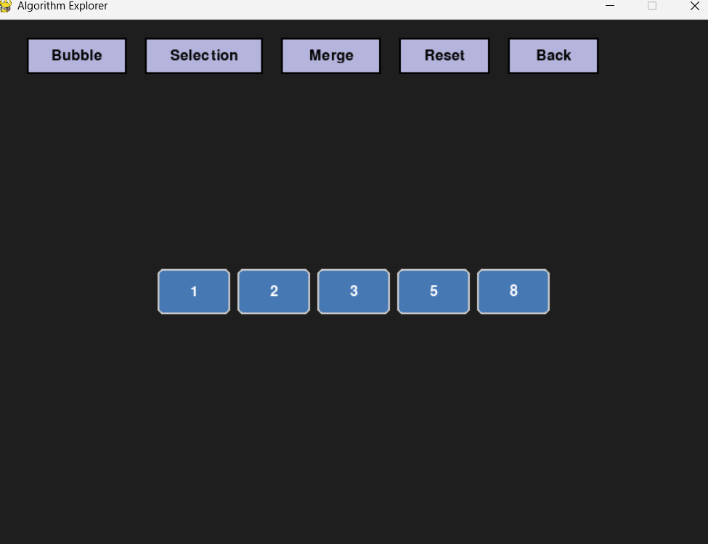

Test Case: Selection sort animation
Description: Ensure colours highlight compared elements
Expected Result: Highlight changes each step correctly

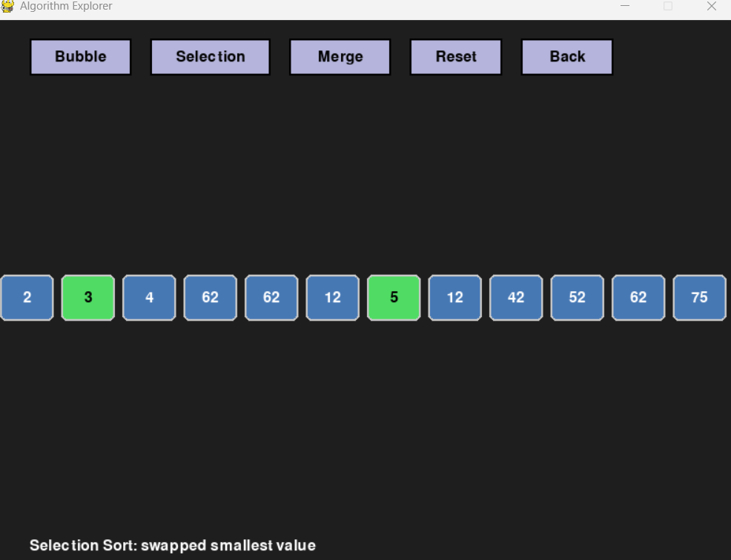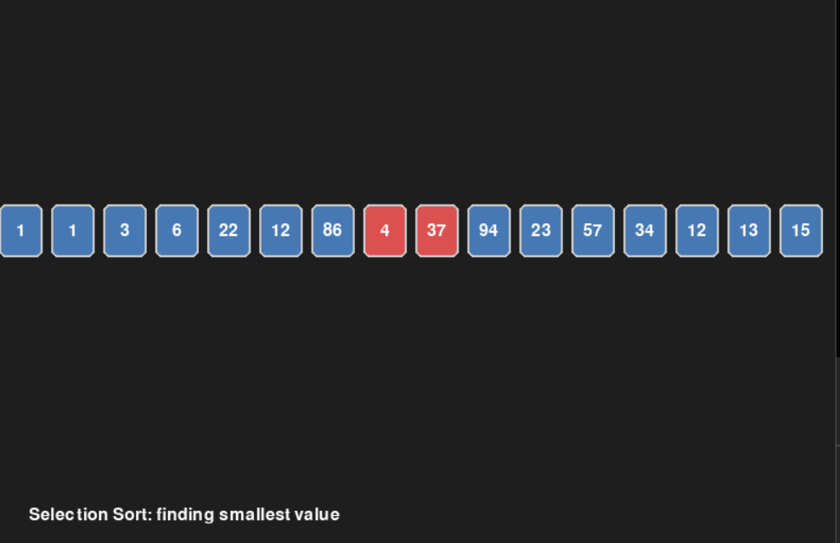

Module 3: Graph Traversal Test Plan
Test Case: BFS traversal from ‘A’
Description: Visit nodes reachable from ‘A’
Expected Result: Nodes visited in correct BFS order
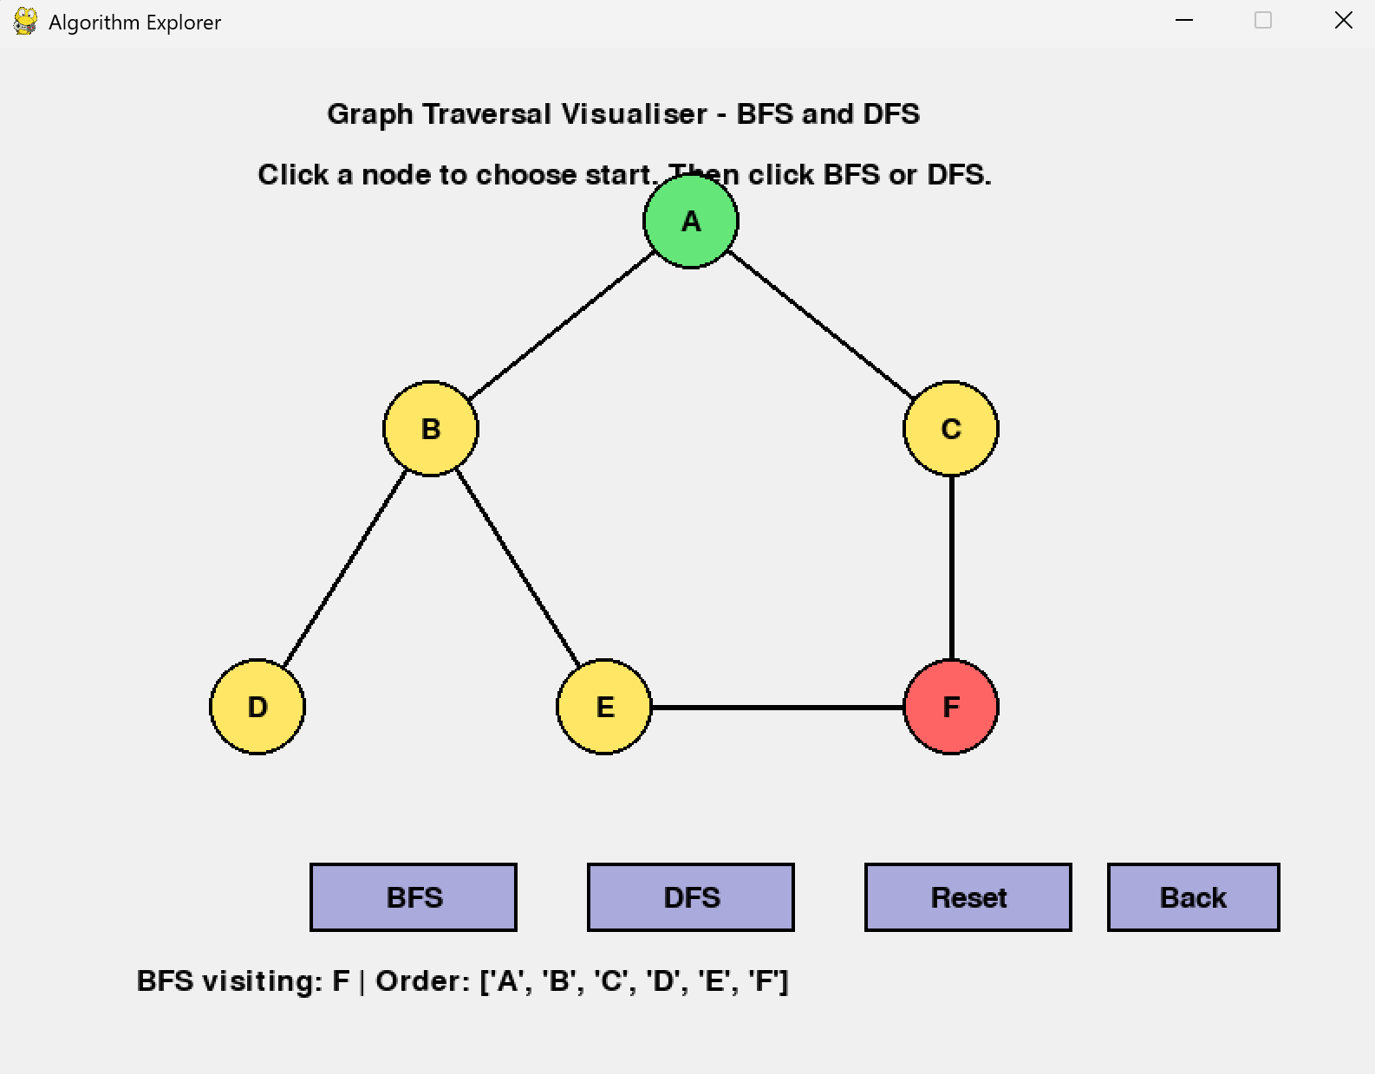

Test Case; DFS traversal from ‘C’
Description: DFS order matches expected path
Expected Result: Traversal path matches theoretical DFS
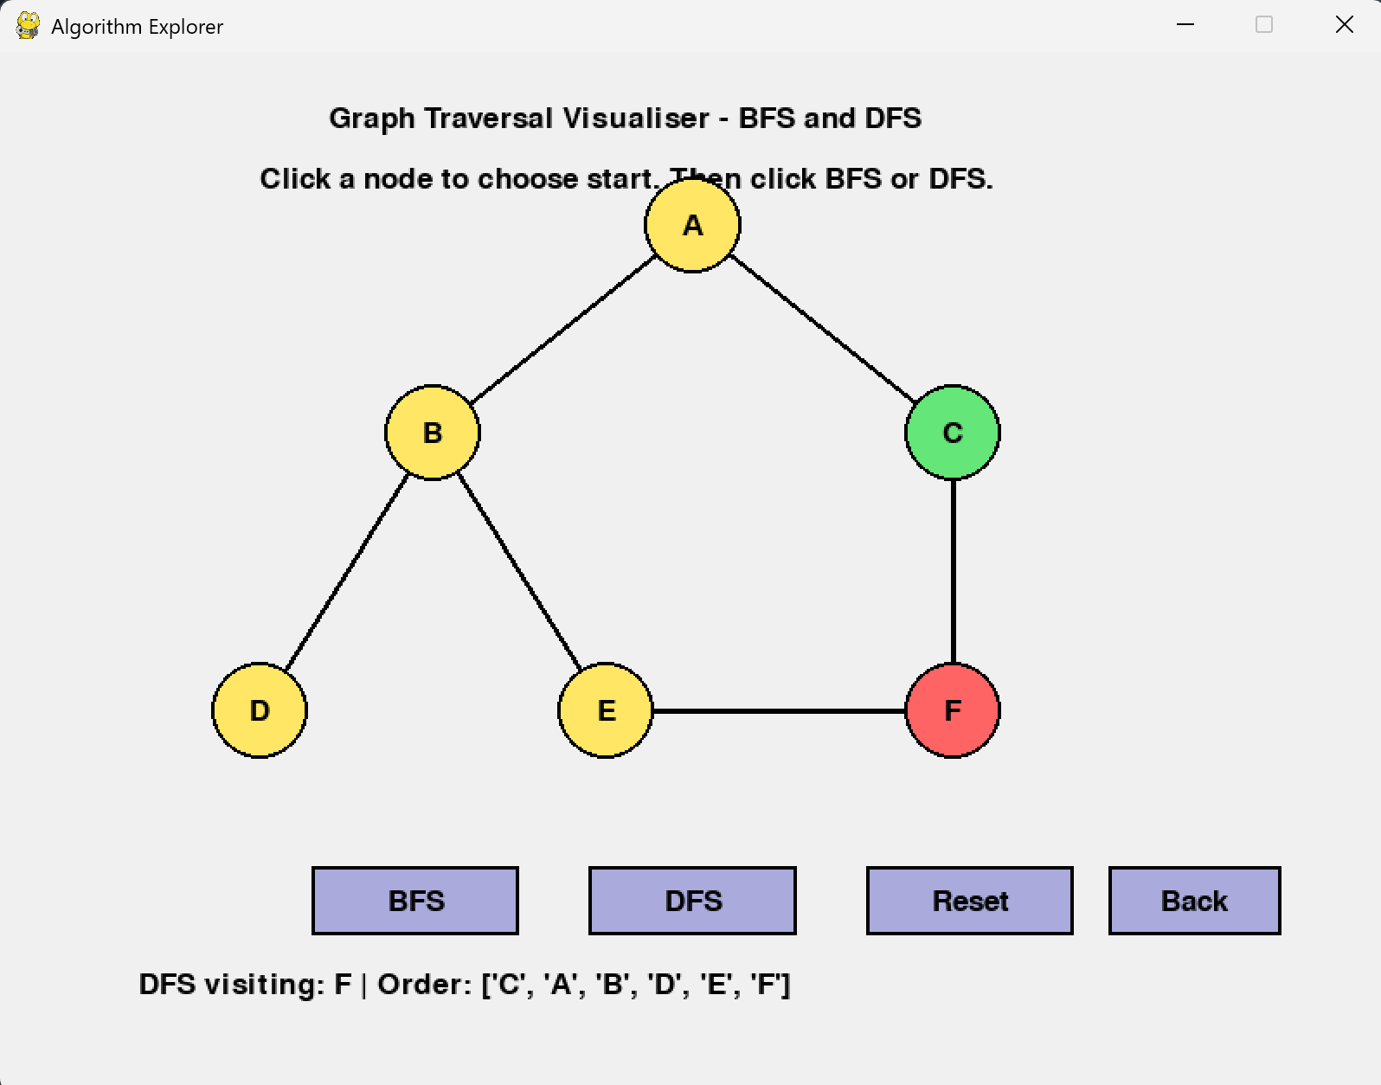

Test Case: Interactive start node
Description: Clicking different nodes
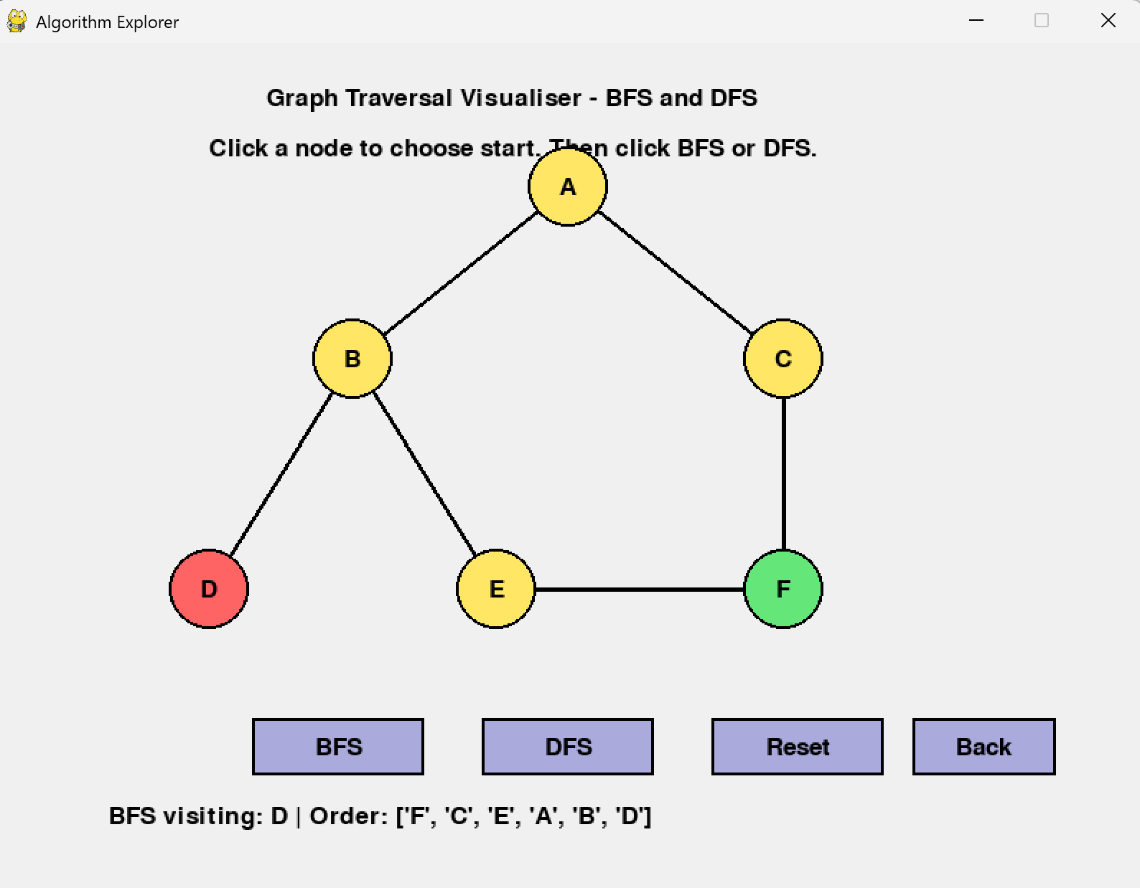
Expected Result: BFS restarts correctly from chosen node
